Information from your Stratford District Safer Neighbourhood Teams (SNTs)

The police encourage all residents to report any policing issues directly to us, as a direct report from a resident is logged onto our database and builds evidence for resources to be applied to issues.

Social media conversations do not contribute to this important data base and reports made by emails to others often delay the recording, action or update on what the police are actively doing to try to deal with incidents, reduce crime and tackle anti-social behaviour.

We would like to signpost and encourage the below ways to best contact us:

Points of contact

999
This is the number to ring if there is an emergency incident happening right now that needs an immediate police presence – if life is at risk, people are injured, offenders are nearby or a crime is in progress.

Reporting online
This is the preferred method to contact police and report any non-emergency issues that do not require an immediate response. This also includes reporting non-emergency collisions and anti-social behaviour. Online reporting is available 24/7 and can be accessed at https://www.warwickshire.police.uk/ro/report

Just reporting
If you simply want to provide information or intelligence without speaking to anyone, this can be done online at https://www.warwickshire.police.uk/tua/tell-us-about/

Operation Snap
You can report and submit digital footage showing potential moving traffic offences online at https://www.warwickshire.police.uk/operationsnap

101
If you are unable to report an issue online but have concerns that do not need an emergency response, this is the number you can use. Please be aware that you may have to wait if the lines are busy, but make sure you have (or receive) an incident number.

Police Station

Stratford Police Station front counter is now back open seven days a week.
Opening times are:
09.00 to 17.00 – Monday - Friday
09.00 to 16.00 – Saturday
11.30 to 14.00 - Sunday
This information is also available on the Warwickshire Police website and is updated regularly at

https://www.warwickshire.police.uk/area/your-area/warwickshire/stratford-on-avon-district/stratford-town/about-us

Crimestoppers
0800 555 111
If you want to report something anonymously, you can contact Crimestoppers. They are an independent charity working to help communities and your anonymity is guaranteed. Search for them online or visit their website at https://crimestoppers-uk.org/

Contacting your Safer Neighbourhood Team (SNT)

If you have information or intelligence and you would rather speak to someone in person, you can speak to any of our SNT while out and about, during one of our station surgeries or public engagements or by emailing your relevant SNT team directly:

Wellesbourne - SNTWellesbourne@warwickshire.police.uk

(Note – Please do not email report of crimes.)

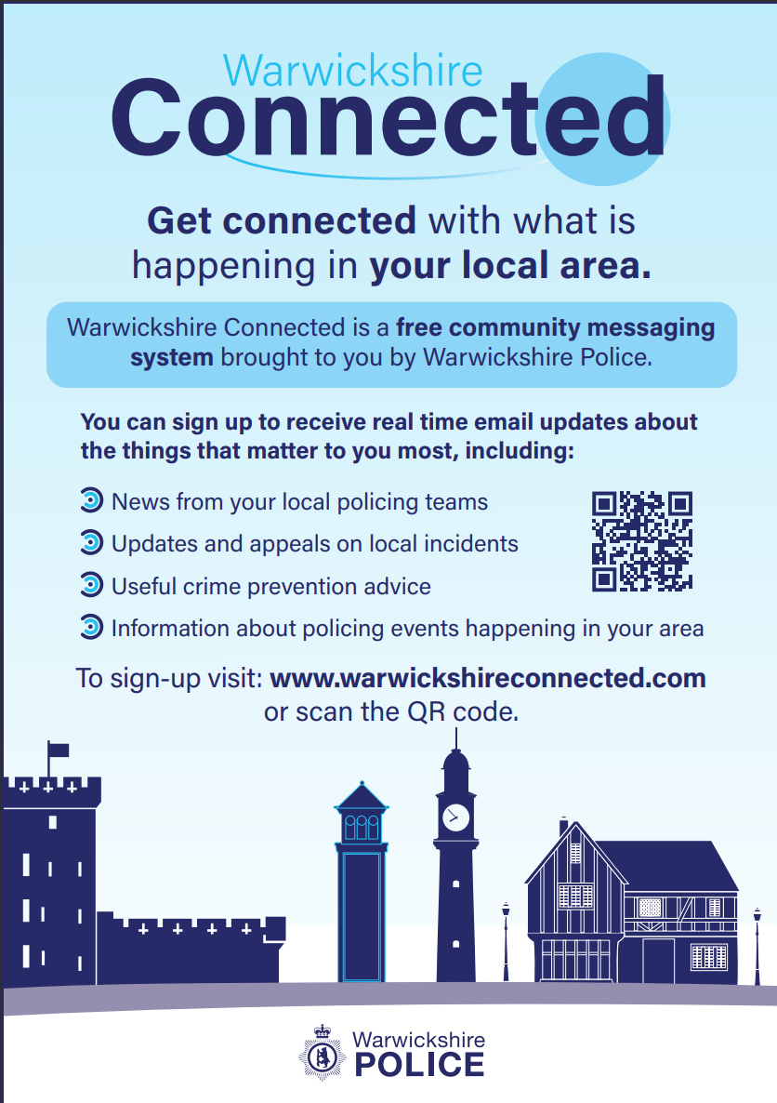
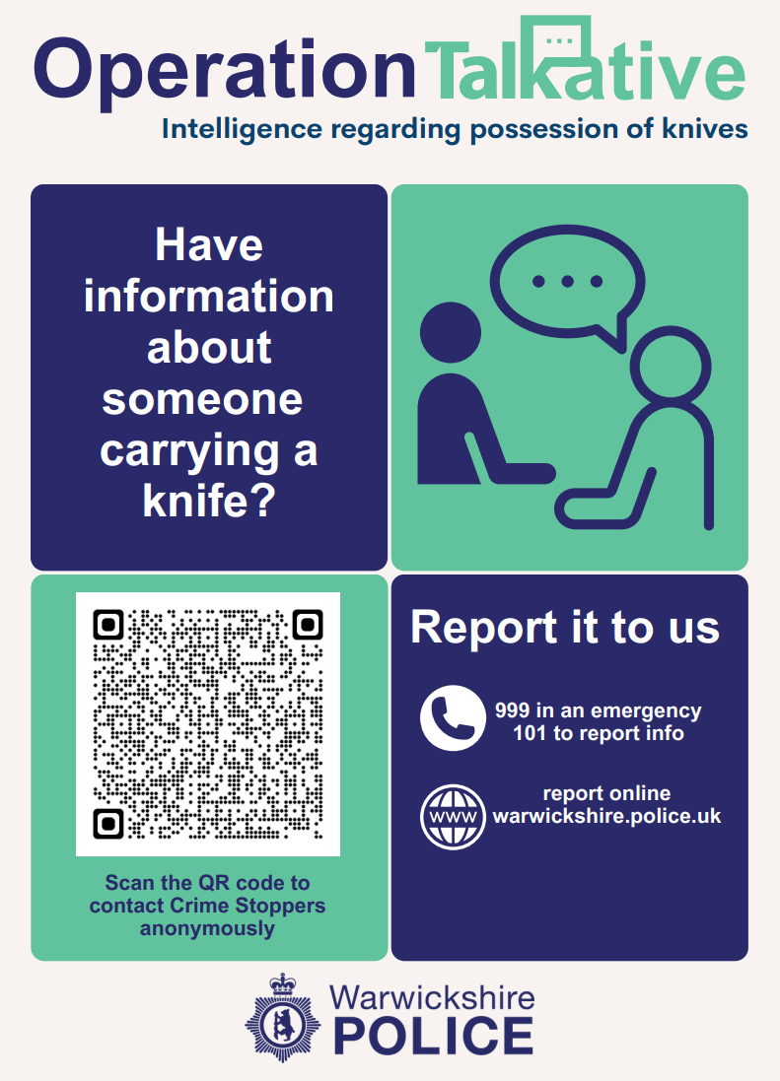
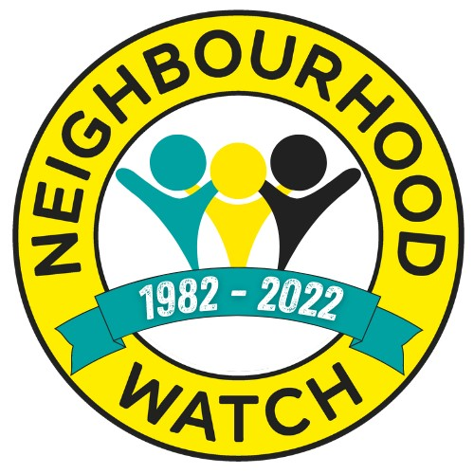Stratford District Neighbourhood Watch Association
Chairperson: Keith Hicks watch4sonad@gmail.com

